Human Resource Ally - Executive Coaching Services

Beyond training courses, seminars and job assignments, Coaching is a critical component of executive development. Coaching provides the opportunity for the executive to practice and implement key concepts so new habits and work behaviors are developed. We believe coaching has a timeline and a clear finish line. While we may often extend or re-engage with clients as new challenges arise, we typically meet with our clients on a weekly basis, over a 12-week timeframe. Our coaching services are designed to help those executives who are high-potential and in the process of moving to new positions, assuming greater responsibility or are not performing at their optimum level and need to improve in targeted areas. We deal with specific, achievable business behavior and the process we use promotes that success.

The Process:
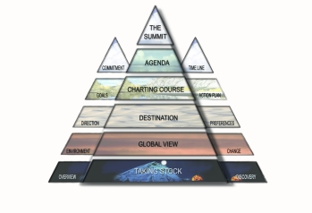 | - Phase 1 - Taking Stock - we set expectation and focus on Self Discovery.  - Phase 2 - Global View - we assess the client's attitude toward change, personal values and the important people in their life & how those people affect the client and provide support.  - Phase 3 - Destination - we identify the client's areas for development, discover the client's motivations and review how to create & communicate expectations.  - Phase 4 - Charting the Course - we will work on specific areas that affect the client's day-to-day work life and structure goals to fit the client's needs.  - Phase 5 - Agenda - we will make sure all is planned for success & set a course for life beyond coaching.  - Phase 6 – Summit - we celebrate the client’s success and hard work toward meeting their goals.

All of our coaches have graduated from one of the six universities who offer the Sherpa Coach Certification, making it the most honored certification available.


